# Backup procedrure OracleProd archive logs

peter.schepens@apollotyres.com

Backups are stored on Sharepoint:  
[R & D Service Desk - Home (sharepoint.com)](https://apollotyres.sharepoint.com/sites/RDSeeviceDesk)

In the directory: Oracleprod-Backup

There are 3 subfolders:

Files are being uploaded to these folders daily.  
The source directories are on Oracleprod itself: E:\Backup

From Sharepoint select one of the 3 folders, for instance: **IS61** and select: Upload.

Be careful to select the correct source folder and then select the files to copy:

Repeat the process for all 3 folders.

From Thursday you can run the backup script on the server:  
E:\Backup\DBA-ADMIN-DAILY-COPY-BACKUP-FILES.bat

This will cleanup the source directory, making sufficient room for the next Full backup on Friday evening.

On Monday I always remove all files older ten 2 weeks from the Sharepoint drive. Then I copy all files, produced during the weekend and on Friday night, to Sharepoint. Except for the biggest file in U611. This one is not accepted by Sharepoint because it is too big.

DD. 19-06-2023

IS61

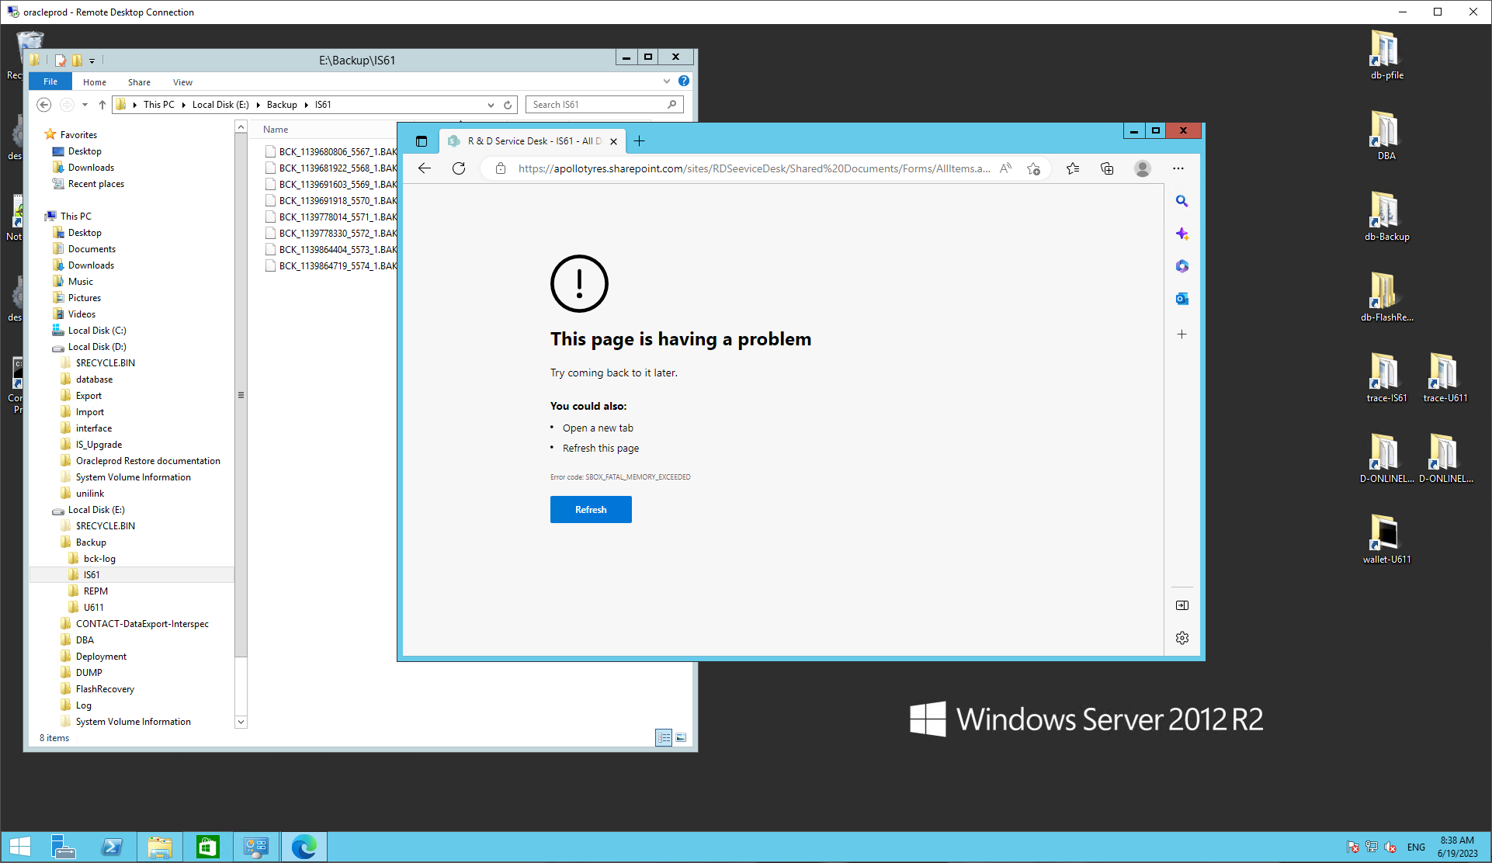

Ongeveer op 7,5 GB al !!!

REPM gaat goed.

U611

De grote backup kan niet ge-upload worden. Deze is te groot !!!

Hoe heeft Patrick deze kunnen uploaden??